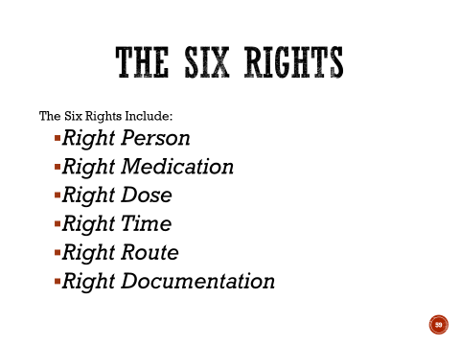

Please = Person
Make = Medication
Dinner = Dose
Tonight = Time
Really = Route
Delicious = Documentation

