Name: __________________________________________Date: ________________________

Employer/Group Home: _________________________________________________________

**Medication Administration Certification Exam** _____________________________________________________________________________

Print your full name and mark your answer on this test. Clear your desk of all other materials. Read the instructions for each section carefully. When you have completed the test, raise your hand and the instructor will come to you to collect the test. There are no breaks allowed during the exam.

_____________________________________________________________________________

Match the example with the Medication Administration Route on the right (Questions 1-6)

_____ 1. Pills, capsules, tablets, or liquids a. Patch

_____ 2. Nose Drops b. Oral (by Mouth)

_____ 3. A medicated adhesive that is placed on the c. Eye

skin to deliver a specific dose of medication  d. Rectal or Vaginal

_____ 4. Suppository

e. Subcutaneous (injected into

_____ 5. Insulin injections tissue just under the skin)

______6. Eye Drops f. Nose

_____________________________________________________________________________

Match the description below with the form of medication on the right (Questions 7-10)

_____ 7. Have a hard coating and should not be a. Liquids

crushed or broken (without a doctor’s order)

b. Patch

_____ 8. Inserted into the vagina or rectum and made

to melt at body temperature c. Enteric Coated (EC) Tablets

_____ 9. Intended for external application to the skin d. Suppositories

_____ 10. Medication dissolved into a syrup

Match the description below with the term on the right (Questions 11 – 15)

_____ 11. When the desired response from a a. Scored Tablet

medication is obtained.

b. Anaphylactic Shock

_____ 12. The way a medication is administered into the

body, such as by mouth, ear/eye, patch, injection c. Therapeutic Effect/

Desired Effect

_____ 13. An order to stop a medication completely.

d. The Route

_____ 14. A serious, life-threatening allergic reaction, may

include swelling of the tongue, lips, may lead to death. e. Discontinuation Order

_____ 15. Tablets that have a line pressed, cut in, or drawn on

them that may be broken to give smaller doses.

_____________________________________________________________________________

**Pharmacy Label**

Rx: #22356 Date Written: 12-18-Year

Sara Dee, RPH 20 Main Street Date Dispensed:

Any Town, MI 09111

Dr. Susan Smith, MD (555) 555-1212

[Date of Birth: 2-2-Year]

lorazepam (Brand Name is ATIVAN)

Take three tablets by mouth at bedtime

Quantity: 90 Tablets

Refills: 1 *Discard 1 year after Date Dispensed

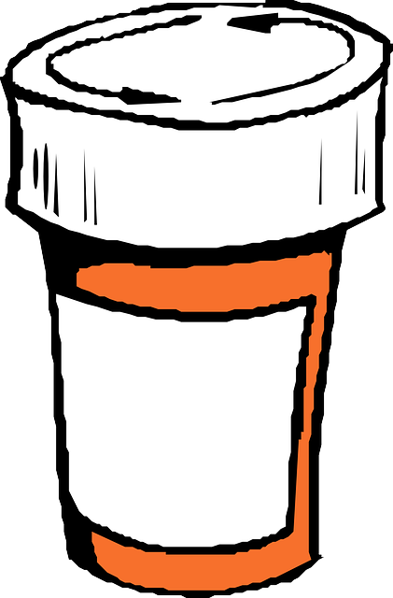

16. Identify the information that is **MISSING** in the above Pharmacy Label:

(Circle Either: A, B, or C)

1. Name of Pharmacy, Date Dispensed, Name of Consumer, Strength of Medication
2. Date Written, Phone Number of Pharmacy, Quantity, Refills

C. Rx Number, Name of Doctor, Pharmacy Address, Name of Medication

**True or False**

17. Having a Medication Administration Record (MAR) with specific scheduled times, such as

8 am, 2 pm, 9 pm, etc., does meet the required time documentation requirements.

a. True

b. False

18. In order to make sure that you have the **Right Person**, you are required to use only one

type of client identifiers when administering medications to a consumer – such as only

the client’s full name.

a. True

b. False

19. The **Right Time** – you can give medication up to 1 hour before or 1 hour after it is

scheduled on the MAR.

a. True

b. False

20. Medications are not required to be stored in the original containers in which the licensed

pharmacist dispensed them, you can put them into Zip-Lock baggies.  
 a. True

b. False

21. To ensure you administer the **Right Medication** and the **Right Dose**, you need to follow the

THREE (3) RULE – check every time that the following THREE (3) ALL MATCH:

The Prescription Order, the Pharmacy Label, and the Medication Administration Record.

a. True

b. False

22. The **Right Documentation** – you are to document immediately after administering a

medication, you are not to document ahead of time or at a later time.

a. True

b. False

23. The **Right Route** is usually measured in micrograms, milligrams, grams, etc.

a. True

b. False

24. Any medication given must have a valid prescription, including Over-the-Counter medication.

All medications must have a pharmacy label, including Over-the-Counter medications.

All medications must be documented on the Medication Administration Record (MAR), including

Over-the-Counter medications.

a. True

b. False

25. A copy of a signed prescription order does not need to be on site to reference when

passing medications.

a. True

b. False

26. Do not force someone to take medication, residents do have the right to refuse.

a. True

b. False

27. Staff are responsible for taking consumers who are prescribed Clozaril to their lab draws

on time so that they can obtain their medications.

a. True

b. False

28. Direct Care Staff do not need a prescription to administer all medications.

a. True

b. False

29. Observing the “Six Rights” is the required and safest way to administer medication and

making it less likely for a medication error to occur. The Six Rights are:

a. The Right ______________________________________________________________

b. The Right ______________________________________________________________

c. The Right ______________________________________________________________

d. The Right ______________________________________________________________

e. The Right ______________________________________________________________

f. The Right ______________________________________________________________

ABBREVIATIONS & SYMBOLS

|  |  |  |  |  |
| --- | --- | --- | --- | --- |
| **Abbreviation** | **Meaning** |  | **Abbreviation** | **Meaning** |
| BID | Two times a day |  | mg | milligram |
| TID | Three times a day |  | ac | Before Meals |
| QID | Four times a day |  | pc | After Meals |
| PO | By Mouth (Oral) |  | h | hour |
| q | Every |  | AM | Morning |
| HS | Bedtime |  | PM | Afternoon |
| PRN | As Needed |  | gtts | Drops |
| OU | Both Eyes |  | mcg | microgram |

Use the above Abbreviation & Symbol Chart to answer the following questions:

Read each question carefully.

**Neurontin 40 mg, 4 Tablets, PO @ HS**

30. What is the strength of an individual tablet of Neurontin?

A. 20 mg

B. 40 mg

C. 1000 mg

31. How many tablets are to be administered?

A. Four Tablets

B. Six Tablets

C. Eight Tablets

32. By what Route is the medication to be administered?

A. By Mouth (Oral)

B. Drops

C. Both Eyes

33. When is this medication to be administered?

A. Every Morning

B. Before Meals

C. At Bedtime

**Copy of Prescription Order**



Vincent Winthrop (Date of Birth: 2-2-1962) Date: 12-18-Year

clonazepam 0.5 mg (Brand Name is KLONOPIN)

Take one tablet by mouth twice a day

Quantity: 62 Tablets

Refills: 2 Doctor’s Signature: Dr. S. Davidson, MD

**Pharmacy Label**

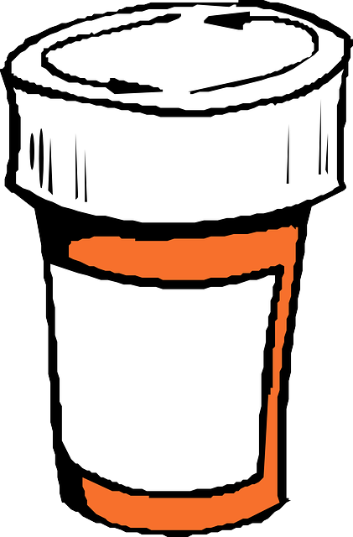

RX# D375284-9726 ABC Pharmacy Date Written: 6-5-Year

R.L. Smith, RPH 20 Main Street Date Dispensed: 6-5-Year

Any Town, MI 09111

Dr. Green Apple, MD 555-555-1212

Vallory Winters [Date of Birth: 10-10-2001]

Cefprozil 250 mg (Brand Name is CEFZIL)

Take two tablets by mouth three times a day

Quantity: 186 Tablets

Refills: 1 Discard this medication 1 year after date dispensed.

**December (Year)** **MEDICATION ADMINISTRATION RECORD Allergies: None**



34. Do all three documents match as they should? (10 pts)

A) Yes

B) No

If they do not match, circle what does not match.

35. Would it be ok to administer this medication on December 18, Year, at 8 pm as scheduled? (10 pts)

A) Yes, because all three documents match as they should.

B) No, because all three documents do not match as they should.

36. What should you do? (10 pts)

A) Administer the medication as scheduled – all three documents match as they should.

B) Do not administer the medication as scheduled – all three documents do not match as they should,

call the doctor, call the pharmacist, call your supervisor and complete an Incident Report (IR).